Go to query browswer

New schema library

New table (id, name, author, year)

In VB.net name new proj

Data grid view

New connecting, enter details

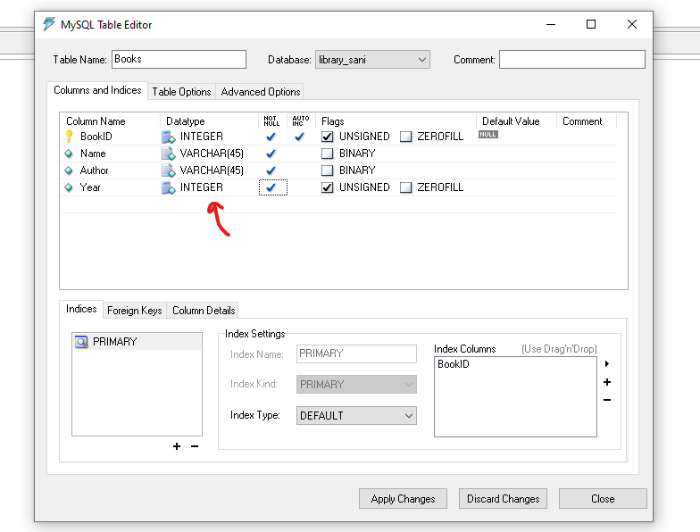

insert into books

Values(01,"Alice in wonderland", "alice whiiteland",1998);

insert into books

Values(02,"Alice in wonderland", "alice whiiteland",1998);

Create a form in vb to take name,author and year input ot add data in the database

